June 2022
Nor’easter


LWML OHIO DISTRICT – NORTHEAST ZONE NEWSLETTER

Zone Officers:
President- Billie Lelle
Vice President – Starshine
Graziadei
Secretary – Sue Matzke
Treasurer – Gayle Hunt

Billie’s Bytes
If you are young at heart, you have probably heard of Bob the Tomato, Larry the Cucumber, Junior Asparagus and the 39 other fruits and vegetables that assume roles to tell Bible stories in the Veggie Tale franchise created by Phil Vicher and Mike Nawocki. The “tales” were created to teach Biblical values and truths.

As I think about “The Lord of the Harvest”, I really don’t think of fields ripe with grain or gardens overflowing with produce (although God certainly gifts us with harvests of food). Instead my mind is drawn to God’s Harvest of souls that has been won through the death and resurrection of His Son, Jesus Christ. Through Word and Sacrament, the Holy Spirit gives a harvest of believers, filled with the fruits of love, joy, peace, patience, kindness, goodness, faithfulness, gentleness, self-control (Galatians 5:22-23a). AND that harvest dear friends is you and me!

While Scripture does speak of harvest as actual food, more often it speaks of the harvest in symbolic terms. Take for instance, Jesus’ words in Matthew 9:38: “therefore pray earnestly to the Lord of the harvest to send out laborers into his harvest.” Later, Paul wrote in 1 Corinthians 3:6-7: “I planted, Apollos watered, but God gave the growth. So neither he who plants nor he who waters is anything, but only God who gives the growth.”

At Thanksgiving, we often use “Sing to the Lord of Harvest” (LBW 893) in our worship services. But the true harvest lies in verse 3 –
Bring to this sacred altar the gifts his goodness gave,
the golden sheaves of harvest, the souls Christ died to save.
Your hearts lay down before him when at his feet you fall,
and with your lives adore him who gave his life for all.

Oh, the joy of being His harvest and being called to live lives of service to Him. The harvest is plentiful, may we as Women in Mission, heed His call with gladness.

In His Love,
Billie (Broccoli ☺ ) Lelle
LWML OH District Northeast Zone President

Upcoming Events
Fall Retreat
September 24
Holy Cross, Madison
“To Gather…Together”
Acts 14:27

Prayer Service – date TBA
Location: Trinity,
Willoughby
Spring Rally – date TBA
Location: Bethel,
Willowick

Page 2 Nor’easter
The Spring Rally, hosted by Zion Lutheran, Painesville on May 7th, was a funfilled event with Christine Woolf as our guest speaker. A trunk full of items was collected “Street Ministy” of Trinity Lutheran, Ohio City. Look for pictures on our website.

To God be the Glory—The stamp collection of Bernd Forwick (Our Redeemer Solon) had been donated to the LWML Ohio District by his wife Anne. To date a large portion of the collection has been sold for over $700. The family has designated that the funds be given to Mites.

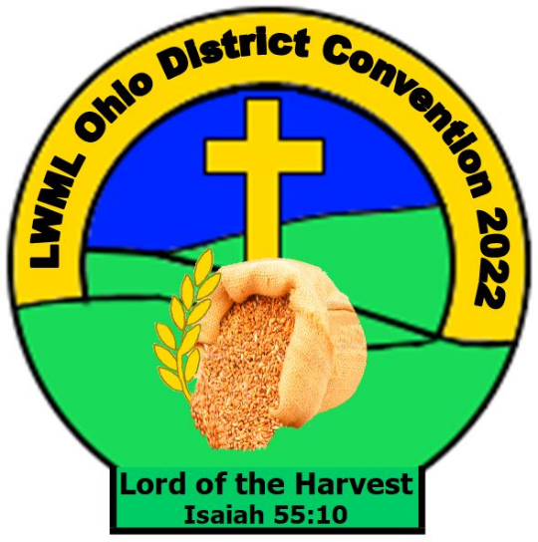
2022 LWML Ohio District
Concise Convention
This new format actually worked quite well with a joy-filled experience, with uplifting opening service, voting on officers and mission grants, inspirational speakers, great music, and a lot of great fellowship.

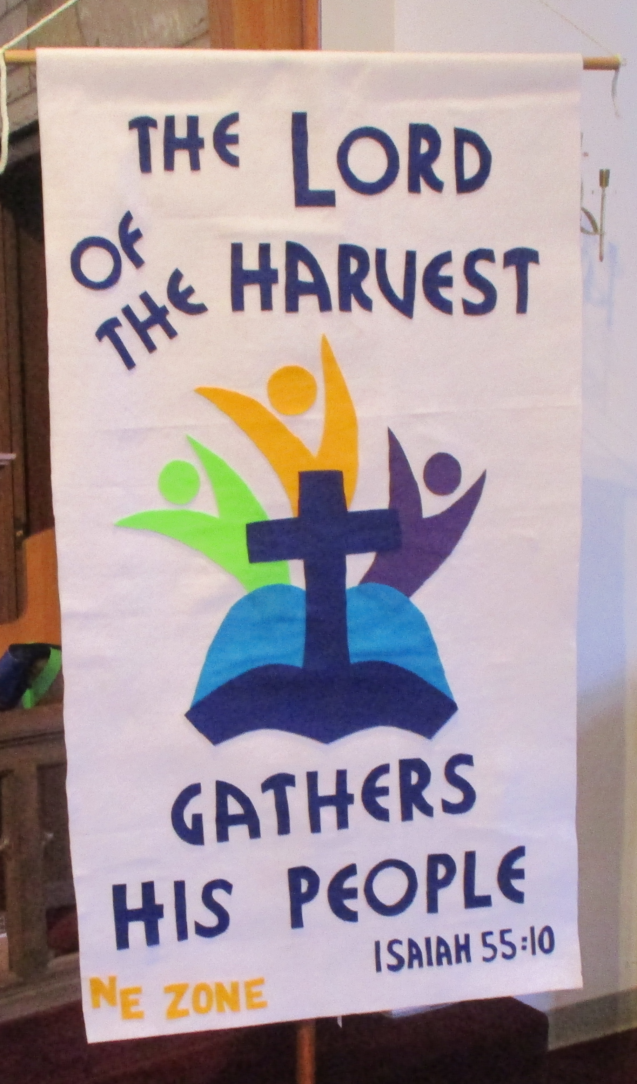
Our zone banner for the LWML Ohio District 2022 convention reminds us that God gathers a harvest of joy-filled believers through the work of His Son. Scripture reveals the story of our salvation and the Holy Spirit works saving faith in us. The banner was designed by Billie Lelle and fashioned by Char LePere
page 3 Nor-easter
“Mitey” Mites
2020-2022 mites, honors, and memorials $147,698.90. All mission grants funded in full

There is now a donate button on http://lwmlohio.org.
One time or recurring donations may be made.
Simply follow the directions, but do remember to include your church name and our zone name (Northeast).



PRAYER WALK EXPERIENCE & OPPORTUNITY – CLEVELAND
What is a Neighborhood Prayer Walk? It’s not just walking around. It’s not just praying. It’s walking through your neighborhood or “parish” praying with your eyes and your heart wide open. It’s noticing signs of hope and signs of need, and how God calls you to be present to both. So get a group. Take a walk. Listen closely. Pay attention. Offer prayer. Take pictures. Maybe even video. Notice what God is up to. Then re-imagine how your ministry could join God and join your neighbors.
Building Hope in the City has scheduled prayer walks in the Clark-Fulton and Stockyards communities. Why not put together a small group and join a walk to see what God is up to in these communities and in your own heart!
Sunday, June 12 from 3:30-4:30 pm (already occurred)
City Life Center, 3340 Trowbridge Ave.
Thursday, July 14 from 6-7 pm
Bethlehem Temple of Praise, 2607 Archwood Ave.
Sunday, August 14 from 3:30-4:30 pm
Bethlehem Temple of Praise, 2607 Archwood Ave.
Thursday, Sept. 8 from 6-7 pm
Primera Iglesia Bautista, 6800 Denison Ave.
Sunday, Oct. 9 from 3:30-4:30 pm
Iglesia Del Salvador, 3023 Clark Ave.
Check out buildinghopeinthecity.org for more information
(Note: Locations vary, so check details closely.)

Page 4 Nor”Easter

Northeast Zone Fall Retreat – September 24, 2022
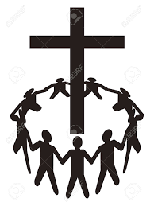
“To Gather Together”

On arriving there, the gathered the church together and reported all that God had done through them and how He had opened the door of faith to the Gentiles. Acts 14:27
Location: Holy Cross Lutheran Church, Madison, OH
Cost: $25.00

Retreat packet will be mailed to each church in the upcoming weeks.
Be sure to look for the information and register to attend this uplifted, fun-filled Zone Event.

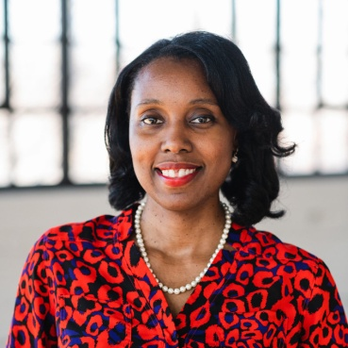
Our Zone Fall Retreat guest speaker will be Vatreisha Nyemba, the Director of Community Development-Building Hope in the City, Cleveland. She will be speaking about LIFT (Leaders In Faith Together), a program that centers around step up the work, effectiveness and overall growth of nonprofit organizations and small business in Cleveland started by people of faith who are following God’s calling in their lives. One of the ministries she will focus on is the Jordan Community Resource Center (Jordan CRC), a faith-based nonprofit founded in 2004. It offers supportive services for women in crisis. Through education and training, this ministry empowers female survivors of human trafficking, Opioid addiction, and re-entry from incarceration. Its mission is to assist in the process of reunification of families, by helping women build a strong foundation in which to become self-confident and self-sufficient. Tenisha Gant Watson is the Founder and CEO of Jordan CRC and may also join us as a speaker at the retreat.



